# HOSPITAL MANAGEMENT SYSTEM

GROUP MEMBERS:-

1. **NAME- HARSHIT CHOPRA**

**ENROLLMENT NO- 20104013 BATCH- B14**

1. **NAME- HARSH VARDHAN GOEL ENROLLMENT NO-20104010 BATCH- B14**
2. **NAME- KARTIK GUPTA ENROLLMENT NO- 20104025 BATCH- B14**

# SUBMITTED TO:- DR. CHETNA DABAS

**ABSTRACT:**

**This project is designed to record all the necessary information that is required in a particular hospital. This code mainly works for two types of information : Doctors information and Patients information. Through this code someone in the hospital management can easily handle all the details of**

**patients like: Room no. , Date of Admit , Age, Name, Medicine fee, Room charge etc. Similarly can also handle all the details of so many doctors like: ID, Name, Age, Qualification, Specialization, Experience, City etc.**

1. **INTRODUCTION:**

**This hospital management system is designed to manage the data of the**

**hospital . It has features to enter the details of doctors and patients , search the particular doctor and patient, generate a patient's report and generate a patient's bill .**

1. **OBJECTIVE:**

**To manage all the data of hospitals easily and to enter , search , compile and add the data and make the process of managing data less time consuming and convenient .**

1. **CLASS DIAGRAM:**

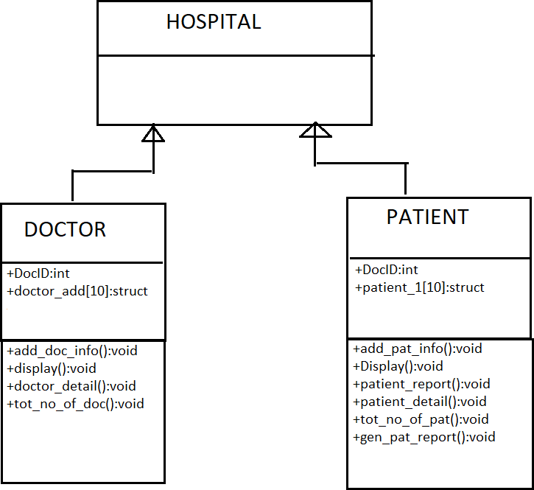

1. **CODE:**

#include<iostream> #include<conio.h> #include<string.h> #include<stdlib.h> #include<stdio.h>

struct doctor1

{

int id;

char name[20],Q[20],age[20],exp[20],city[20],special[20];

};

struct patient1

{

int id1;

char name[20],age[20],city[20],dis[20],room[20],sym[20],con[20],date[20],

charg[20],bill[20];

};

using namespace std; class doctor;

class patient; class hospital

{

public:

// int id=0,id1=0, int counter=0;

};

class doctor:public hospital

{

public:

int docid=0;

struct doctor1 arr[10]; void add_doc_info()

{

int i,en;

cout<<"How Many Entries you want to add :"; cin>>en;

for(i=1;i<=en;i++)

{

cout<<"Enter Doctor's ID :"; cin>>arr[docid].id;

cout<<"Enter Doctor's Name :"; cin>>arr[docid].name;

cout<<"Enter Doctor's Age :"; cin>>arr[docid].age;

cout<<"Enter Doctor's Qualification :"; cin>>arr[docid].Q;

cout<<"Enter Doctor's Specialization :"; cin>>arr[docid].special;

cout<<"Enter Doctor's Experience :"; cin>>arr[docid].exp;

cout<<"Enter Doctor's city :"; cin>>arr[docid].city;

docid++; counter++; cout<<"\n";

cout<<"You filled all Entries of "<<i<<" doctor successfully"<<"\n"; cout<<"enter value for "<<" "<<i+1<<" "<<"doctor"<<"\n";

}

}

void Display()

{

int n,i;

cout<<"\n Enter the doctor's ID to display Record :"; cin>>n;

if(n==0)

{

cout<<"\n\n OOPS!!!! "<<"\n\n";

cout<<"Note:- No Record To Display Plz Go Back And Enter Some Entries. "<<"\n";

}

else

{

int status=0; for(i=0;i<docid;i++)

{

if(arr[i].id==n)

{

status=1; break;

}

}

if(status)

{

cout<<"\n\n";

cout<<"1.Doctor's ID :"<<arr[i].id<<"\n"; cout<<"2.Doctor's Name :"<<arr[i].name<<"\n"; cout<<"3.Doctor's Age :"<<arr[i].age<<"\n"; cout<<"4.Doctor's Qualification :"<<arr[i].Q<<"\n"; cout<<"5.Doctor's Specialization :"<<arr[i].special<<"\n"; cout<<"6.Doctor's Experience :"<<arr[i].exp<<"\n"; cout<<"8.Doctor's city :"<<arr[i].city<<"\n"; cout<<" \n Press Any KEY To choose another Option. ";

}

else

{

cout<<" \n\n No such ID in database "<<endl;

cout<<" \n Press Any KEY To choose another Option. ";

}

}

getch();

}

void doctor_detail()

{

int i; if(docid==0)

{

cout<<" \n\n\n OOPS!!!! "<<"\n\n"; cout<<"Note:- No Record To Display Plz Go Back And Enter Some

Entries. "<<"\n";

}

else{

cout<<"**********"<<"\n";

cout<<"\t \t \t Details Of All The Doctors In The Hospital \n"; cout<<"**********"<<"\n \n";

cout<<"ID"<<"\t \t"<<"specialization"<<"\t \t"<<"Qualification"<<"\t \t"<<"Age"; cout<<"\n \n";

for(i=0;i<docid;i++)

{

cout<<arr[i].id<<"\t \t"<<arr[i].special<<"\t \t \t"<<arr[i].Q<<"\t \t

\t"<<arr[i].age<<"\n";

}

cout<<" \n Press Any Button To choose another Option. ";

}

getch();

}

void tot_no_of_doc()

{

int i=counter;

cout<<"Total Doctor's in Hospital : "<<i<<"\n";

cout<<" \n Press Any Button To choose another Option. ";

getch();

}

};

class patient:public hospital

{

public:

int docid1=0;

struct patient1 arr[10];

void add_pat_info(); void Display();

void patient_report(); void patient_detail(); void tot_no_of_pat(); void gen_pat_report();

};

void patient :: add_pat_info()

{

int i,en;

cout<<"How Many Entries you want to add :"; cin>>en;

for(i=1;i<=en;i++)

{

cout<<" 1.Enter Patient's ID :"; cin>>arr[docid1].id1;

cout<<" 2. Enter patient's Name :"; cin>>arr[docid1].name;

cout<<"3. Enter patient's Age :"; cin>>arr[docid1].age;

cout<<" 4. Enter patient's Disease :"; cin>>arr[docid1].dis;

cout<<" 5. Enter patient's Symptoms :"; cin>>arr[docid1].sym;

cout<<" 6. Enter Patient's Room No. :"; cin>>arr[docid1].room;

cout<<" 7. Enter Patient's condition Before Admit :"; cin>>arr[docid1].con;

cout<<" 8. Enter Patient's ADMIT Date :"; cin>>arr[docid1].date;

cout<<" 9. Enter Patient's Room Charge :"; cin>>arr[docid1].charg;

cout<<" 10. Enter Patient's Medicine charge :"; cin>>arr[docid1].bill;

docid1++; counter++; cout<<"\n";

cout<<"You filled all Entries of "<<i<<" patient successfully"<<"\n"; cout<<"enter value for "<<" "<<i+1<<" "<<"patient"<<"\n";

}

}

void patient :: Display()

{

int n,i;

cout<<"\n Enter the Patient's ID to display info :"; cin>>n;

if(n==0)

{

cout<<"\n\n OOPS!!!! "<<"\n \n";

cout<<"Note:- No Record To Display Plz Go Back And Enter Some Entries. "<<"\n";

cout<<" \n Press Any KEY To choose another Option. ";

}

else

{

int status=0; for(i=0;i<docid1;i++)

{

if(arr[i].id1==n)

{

status=1; break;

}

}

if(status==1)

{

cout<<"1.Patient's ID :"<<arr[i].id1<<"\n"; cout<<"2.Patient's Name :"<<arr[i].name<<"\n";

cout<<"3.Patient's Age :"<<arr[i].age<<"\n";

cout<<"4.Patient's Disease :"<<arr[i].dis<<"\n";

cout<<"5.Patient's Symptoms :"<<arr[i].sym<<"\n";

cout<<"6.Patient's Room No. :"<<arr[i].room<<"\n"; cout<<"7.Patient's condition Before Admit :"<<arr[i].con<<"\n"; cout<<"8.Patient's ADMIT Date :"<<arr[i].date<<"\n";

cout<<"9.Patient's Room Charge :"<<arr[i].charg<<"\n";

cout<<"10.Patient's Medicine charge :"<<arr[i].bill<<"\n"; cout<<" \n Press Any KEY To choose another Option. ";

}

else{

cout<<" \n\n No such ID in database "<<endl;

cout<<" \n Press Any KEY To choose another Option. ";

}

}

getch();

}

void patient :: patient_report()

{

int i,n;

cout<<"\n Enter the Patient's ID to Display Report :"; cin>>n;

int status=0; for(i=0;i<docid1;i++)

{

if(arr[i].id1==n)

{

status=1; break;

}

}

if(status)

{

cout<<"\n\n * Patient's Report * "<<"\n \n";

cout<< "1. Patient's Name "<<arr[i].name<<"\n";

cout<< "2. Patient's Age "<<arr[i].age<<"\n"; cout<< "3. Patient symptoms "<<arr[i].sym<<"\n";

cout<< "4. Patient Disease "<<arr[i].dis<<"\n";

cout<< "5. Patient Admit Date "<<arr[i].date<<"\n"; cout<< "6. Patient condition At The Time Of Discharge

"<<arr[i].con<<"\n";

cout<<"Press Any Key To Go Back. ";

}

else{

cout<<" \n\n No such ID in database "<<endl;

cout<<" \n Press Any KEY To choose another Option. ";

}

getch();

}

void patient:: patient_detail()

{

int i; if(docid1==0)

{

cout<<" \n\n\n\n\n OOPS!!!! "<<"\n\n\n"; cout<<"Note:- No Record To Display Plz Go Back And Enter Some

Entries. "<<"\n";

}

else{ cout<<"**********"<<"\n";

cout<<"\t \t \t Details Of All The Pateint In The Hospital \n"; cout<<"**********"<<"\n \n";

cout<<"ID"<<"\t \t"<<"illness"<<"\t \t"<<"ADMITTED Date"<<"\t \t"<<"Age"; cout<<"\n \n";

for(i=0;i<docid1;i++)

{

cout<<arr[i].id1<<"\t \t"<<arr[i].dis<<"\t \t \t"<<arr[i].date<<"\t \t

\t"<<arr[i].age<<"\n";

}

cout<<" \n Press Any KEY To choose another Option. ";

}

getch();

}

void patient :: tot_no_of_pat()

{

int i=counter;

cout<<"Total Patients in Hospital : "<<i<<"\n";

cout<<" \n Press Any KEY To choose another Option. ";

getch();

}

void patient :: gen_pat_report()

{

int i,n;

cout<<"\n Enter the Patient's ID to Display Bill :"; cin>>n;

int status=0; for(i=0;i<docid1;i++)

{

if(arr[i].id1==n)

{

status=1; break;

}

}

if(status)

{

cout<<"\n\n * Patient's Report * "<<"\n \n";

cout<< "1. Patient's Medicine Charge "<<arr[i].bill<<"\n";

cout<< "2. Patient's Room Charge "<<arr[i].charg<<"\n"; cout<<"Press Any Key To Go Back. ";

}

else{

cout<<" \n\n No such ID in database "<<endl;

cout<<" \n Press Any KEY To choose another Option. ";

}

getch();

}

int main()

{

bool repeat= true; int ch1,ch2,ch3,ch4; doctor d;

patient p; xyz:

cout<<"\n\n";

cout<<" * Welcome to the Hospital Management System * "<<"\n\n\n"; cout<<" 1. Menu : "<<"\n\n";;

cout<<" 2. Exit : "<<"\n\n\n\n"; cout<<"Enter Your Choice :";

cin>>ch1; cout<<"\n\n\n";

if(ch1==1)

{

xyz2:

cout<<"\n\n";

cout<<" 1. Enter into Doctor's DataBase "<<endl; cout<<" 2. Enter into Patient's DataBase "<<endl; cout<<" 3. Generate Patient's Report "<<endl; cout<<" 4. Generate Patient's Bill "<<endl; cout<<" 5. EXIT "<<"\n";

cout<<"Please Enter Your choice :"<<" "; cin>>ch2;

while(repeat==true)

{

switch(ch2) case 1:

{

cout<<"\n\n";

cout<<" * Welcome To Doctor's DataBase * "<<"\n \n \n\n";

|  |  |  |  |
| --- | --- | --- | --- |
| cout<< | " \t | 1. Add New Doctor's Information | "<<endl; |
| cout<< | " \t | 2. Display Doctor's Information | "<<endl; |
| cout<< | " \t | 3. Detail OF ALL The Doctors In The Hospital "<<endl; | |
| cout<< | " \t | 4. Total Number of Doctor's in Hospital "<<endl; | |
| cout<< | " \t | 5. EXIT "<<"\n"; | |

cout<<"Please Enter your choice :"<<" "; cin>>ch3;

switch(ch3)

{

case 1: d.add_doc_info(); break;

case 2:

d.Display(); cout<<"\n";

break; case 3:

d.doctor_detail(); break;

case 4:

d.tot_no_of_doc(); break;

case 5:

goto xyz2; break;

default: cout<<"invalid";

}

break; case 2:

cout<<"\n\n";

cout<<" * Welcome To Patient's DataBase * "<<"\n \n";

cout<< "1. Add New Patient's Information "<<endl; cout<< "2. Display Patient's Information "<<endl; cout<< "3. Detail OF ALL The Patient In The Hospital "<<endl; cout<< "4. Total Number of Patient's in Hospital "<<endl; cout<< "5. EXIT "<<"\n";

cout<<"Please Enter your choice :"<<" "; cin>>ch4;

switch(ch4)

{

case 1:

p.add_pat_info(); break;

case 2:

p.Display(); cout<<"\n";

break;

case 3:

p.patient_detail(); break;

case 4:

p.tot_no_of_pat(); break;

case 5:

goto xyz2; break;

default: cout<<"invalid"; break;

}

break; case 3:

p.patient_report(); goto xyz2;

break; case 4:

p.gen_pat_report();

goto xyz2; break;

case 5:

goto xyz; break;

}

}

}

else if(ch1==2)

{

return 0;

}

else

{

cout<<"Wrong Input"<<endl;

}

return 0;

}

# RESULTS AND DISCUSSION:

After running the program the first output window we get 2 choices:

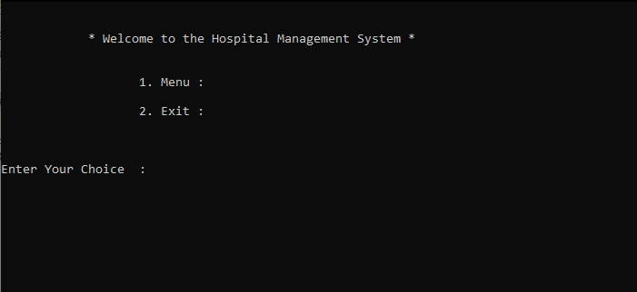

* 1. **Entering choice - 1 to open Menu**

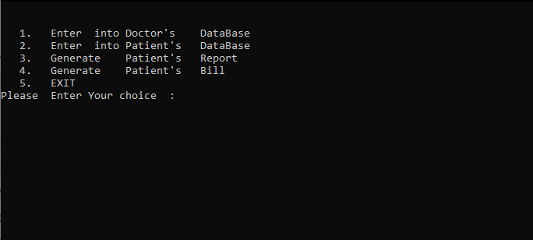

* + 1. **Entering choice - 1 to enter into doctor’s database**

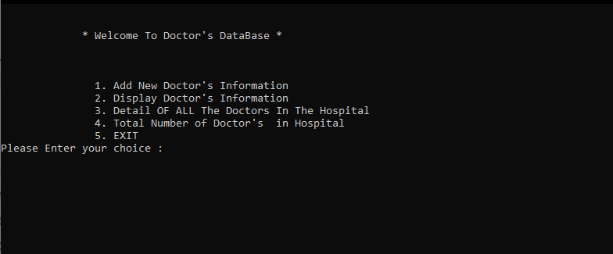

* + - 1. **Entering choice - 1 to add information of doctors like their unique ID, Name,Age,etc. into doctor’s database**

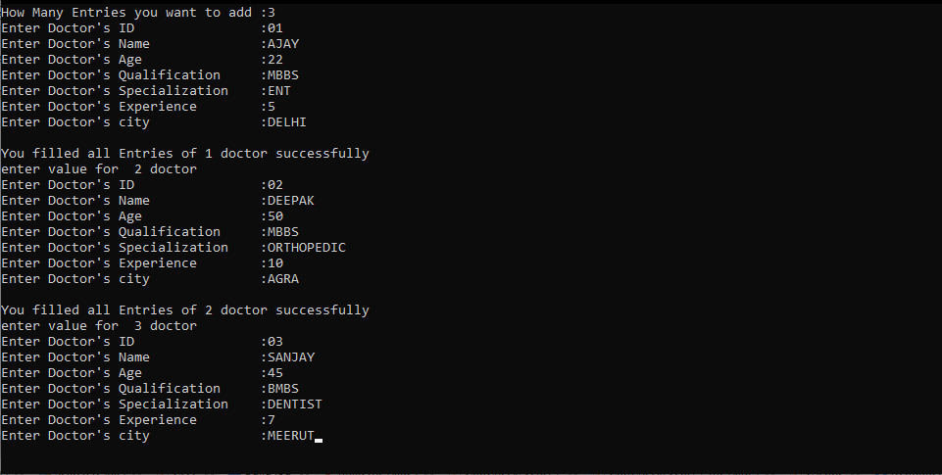

* + - 1. **Entering choice - 2 to get information about a particular doctor by entering their unique ID**

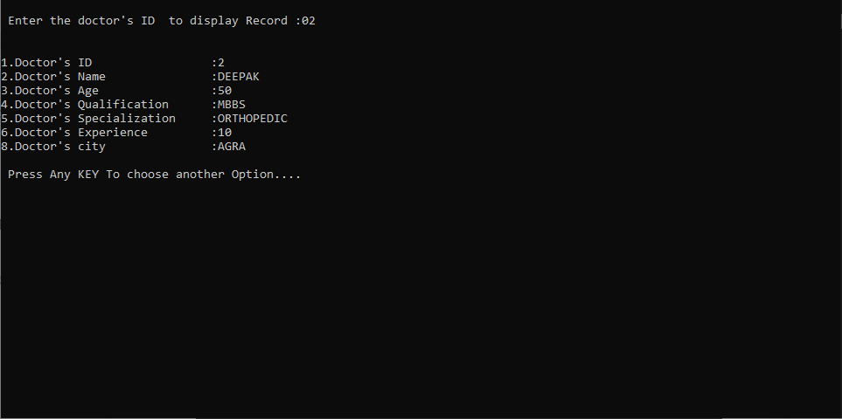

* + - 1. **Entering Choice-3 to display information of all doctors present in the database**

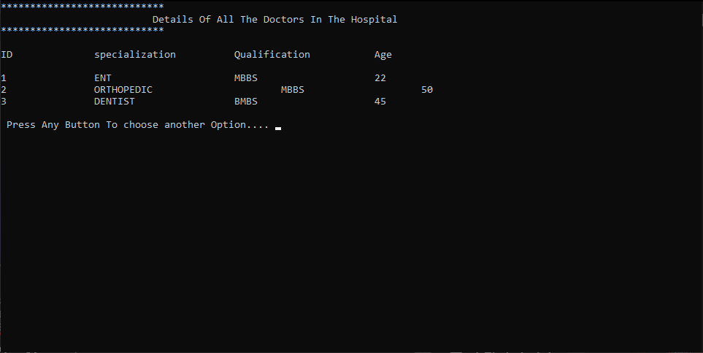

* + - 1. **Entering Choice- 4 to display total numbers of doctors**

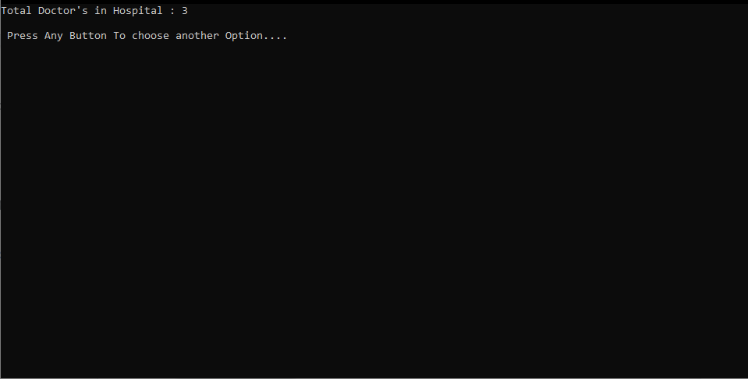

* + 1. **Entering Choice-2 in Menu window to open Patient’s Database**

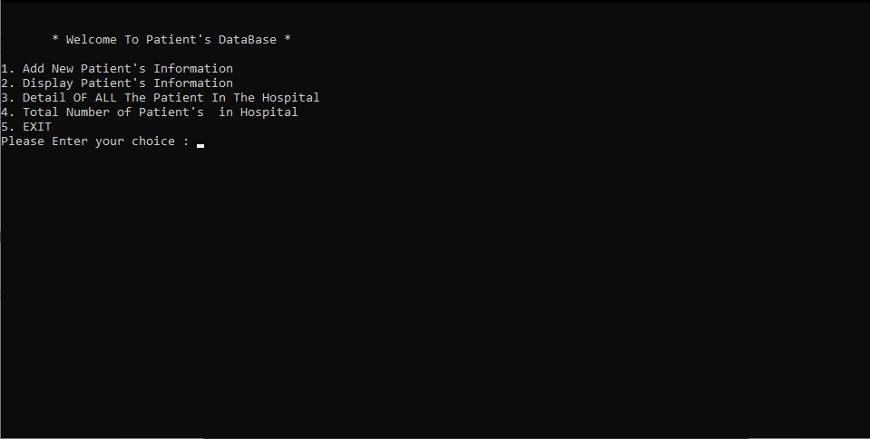

* + - 1. **Entering choice - 1 to add information of Patients like their unique ID, Name,Age,Disease,Etc. into patient's database**

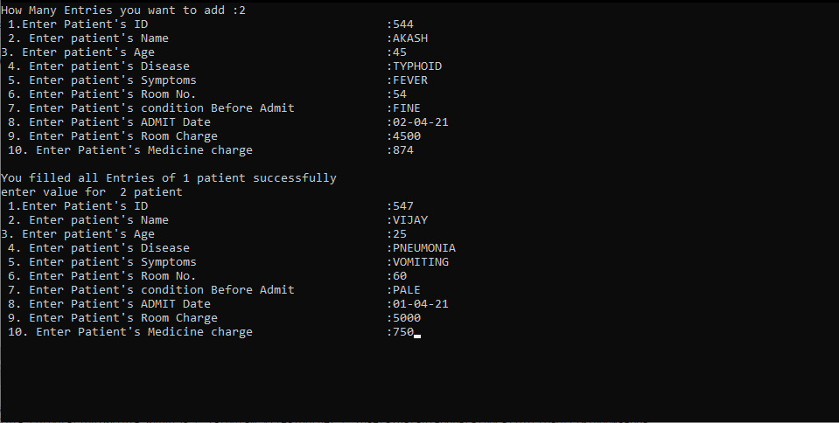

* + - 1. **Entering choice - 2 to get information about a particular doctor by entering their unique ID**

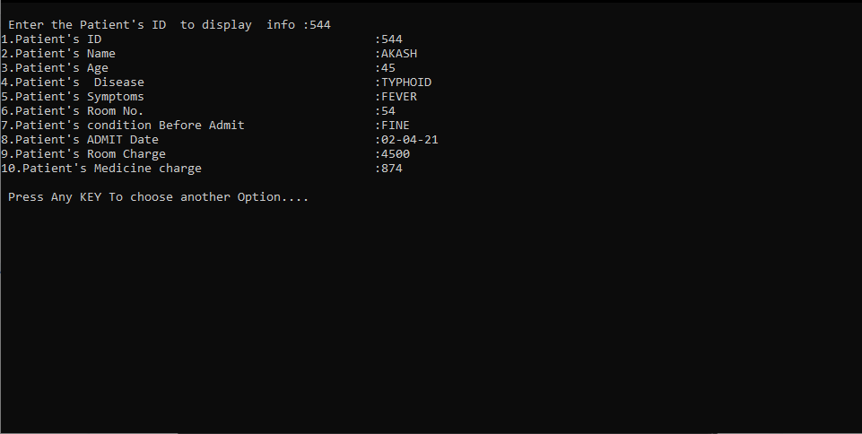

* + - 1. **Entering Choice-3 to display information of all doctors present in the database**

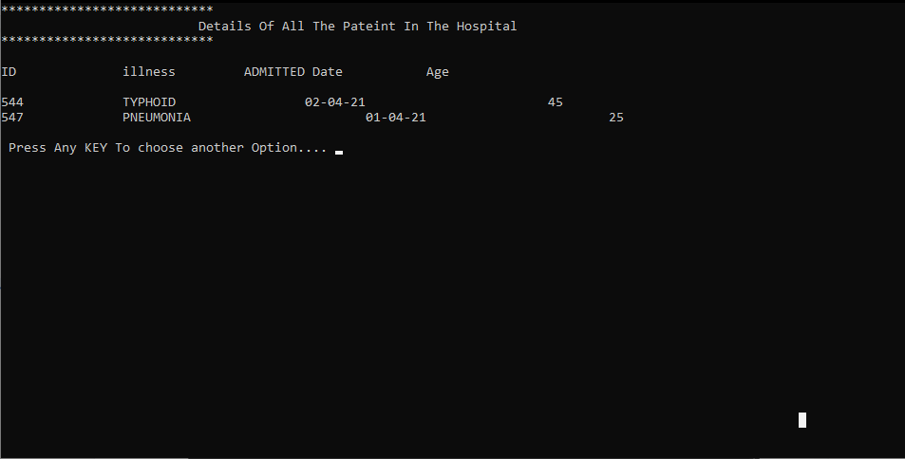

* + 1. **Entering Choice-3 in Menu window to open Patient’s Report database to get report of a particular patient by entering their Unique ID**

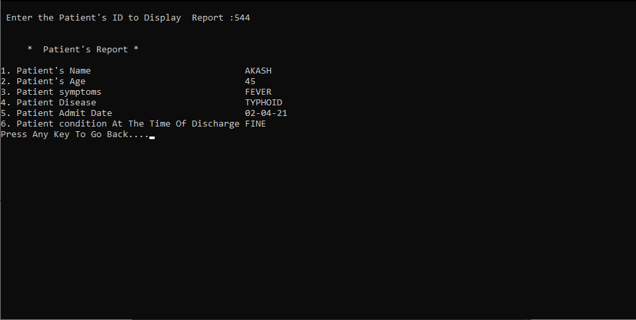

* + 1. **Entering Choice-4 in Menu window to open Patient’s Bill database to get total bill of a particular patient by entering their Unique ID**

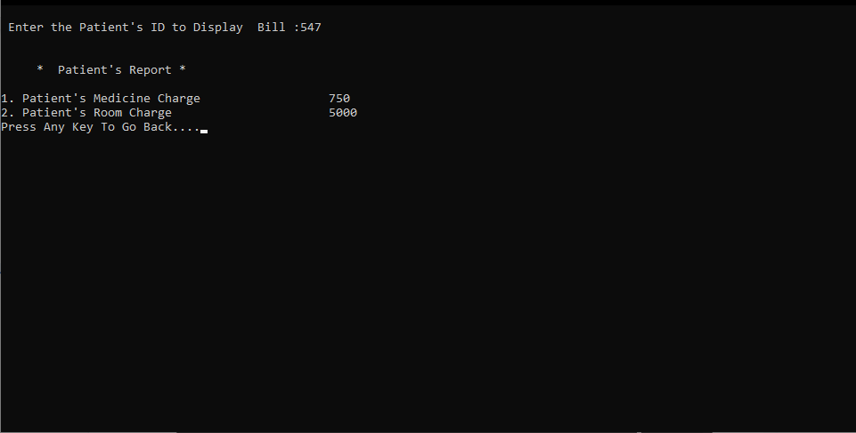

1. **CONCLUSUON:**

**This program will reduce human efforts to manage a database in a hospital. It will help to manage a hospital by giving just a single digit input. It will also reduce the chances of mistakes and can store the data safely in your device rather than maintaining the data manually.**

1. **REFERENCES:**
2. **Computer Science With C++ by Sumita Arora**
3. **C++: The Complete Reference, 4th Edition by** [**Herbert Schildt**](https://www.amazon.in/Books-Herbert-Schildt/s?rh=n%3A976389031%2Cp_27%3AHerbert%2BSchildt)